Train Ticket Booking System
Problem Statement :
In many railway reservation centers, ticket booking, passenger management, payment handling, and seat allocation are often handled manually or through poorly integrated systems. This leads to booking errors, seat duplication, payment mismatches, difficulty in tracking passenger records, and poor management of train seat availability. Users may face problems such as double booking, incorrect fare calculation, and lack of clear booking history.
To solve these issues, a Train Ticket Booking System is designed using Object-Oriented Programming principles. The system automates user registration, train management, ticket generation, booking handling, and payment processing. Each booking is linked to a unique ticket and payment record, ensuring accuracy, security, and easy tracking of travel information.

Key Features of the System:
1 User registration and profile management
2 Train information management including seat availability
3 Ticket generation with unique Ticket ID
4 Booking management with date and time tracking
5 Seat allocation and fare calculation
6 Payment processing and payment status verification
7 Booking cancellation with ticket status update
8 Viewing booking history and ticket details
9 Data consistency between User, Ticket, Booking, Train, and Payment modules

System Objectives:
1 Reduce manual errors in ticket booking and payment
2 Ensure proper seat management and availability tracking
3 Maintain secure and structured passenger data
4 Provide clear booking and payment records
5 Model real-world railway reservation operations.

UML Diagram :
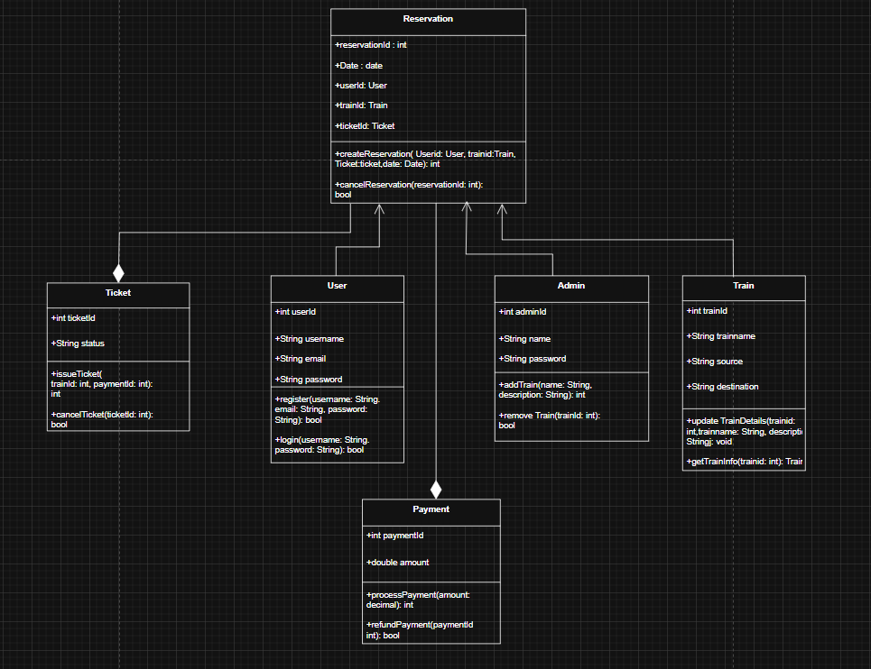

Program :

1.Reservation :

import java.util.ArrayList;
import java.util.List;
import java.util.Scanner;

public class Reservation {
public static void main(String[] args) {
Scanner sc = new Scanner(System.in);
List<Train> trains = new ArrayList<>();
trains.add(new Train("Express", "Fast train between A and B"));
trains.add(new Train("Local", "Stops at every station"));

User currentUser = null;
Admin adminUser = new Admin("admin", "admin@example.com", "adminpass");

outer: while (true) {
System.out.println("\nSelect role: \n1) User\n2) Admin\n3) Exit");
System.out.print("Choice: ");
String choice = sc.nextLine().trim();
switch (choice) {
case "1": // user
userMenu(sc, trains, currentUser);
break;
case "2": // admin
adminMenu(sc, trains, adminUser);
break;
case "3":
break outer;
default:
System.out.println("Invalid choice");
}
}

sc.close();
System.out.println("Exiting.");
}

private static void userMenu(Scanner sc, List<Train> trains, User currentUser) {
User loggedInUser = currentUser;
while (true) {
System.out.println("\nUser Menu:\n1) Signup\n2) Login\n3) Back");
System.out.print("Choice: ");
String c = sc.nextLine().trim();
if (c.equals("1")) {
System.out.print("Username: ");
String uname = sc.nextLine().trim();
System.out.print("Email: ");
String email = sc.nextLine().trim();
System.out.print("Password: ");
String pass = sc.nextLine().trim();
User u = new User();
boolean ok = u.registerUser(uname, email, pass);
if (ok) {
loggedInUser = u;
System.out.println("Signup successful. Logged in as " + uname);
userActions(sc, trains, loggedInUser);
return;
} else {
System.out.println("Signup failed. Try again.");
}
} else if (c.equals("2")) {
System.out.print("Username: ");
String uname = sc.nextLine().trim();
System.out.print("Password: ");
String pass = sc.nextLine().trim();
User u = new User();
// In this simple demo we only verify against a user object created earlier in session
if (u.login(uname, pass)) { // this will be false unless same object was used
loggedInUser = u;
System.out.println("Login successful.");
userActions(sc, trains, loggedInUser);
return;
} else {
System.out.println("Login failed (demo: create an account with Signup first).");
}
} else if (c.equals("3")) {
return;
} else {
System.out.println("Invalid choice");
}
}
}

private static void userActions(Scanner sc, List<Train> trains, User user) {
while (true) {
System.out.println("\nUser Actions:\n1) List trains\n2) Ticket booking\n3) Ticket price\n4) Booking history\n5) Logout");
System.out.print("Choice: ");
String a = sc.nextLine().trim();
switch (a) {
case "1":
System.out.println("Available trains:");
for (Train t : trains) {
System.out.println("- id=" + t.getId() + " name=" + t.getName() + " desc=" + t.getDescription());
}
break;
case "2":
System.out.println("Choose train id to book:");
for (Train t : trains) System.out.println(t.getId() + ": " + t.getName());
System.out.print("Train id: ");
String tidStr = sc.nextLine().trim();
try {
int tid = Integer.parseInt(tidStr);
Train chosen = null;
for (Train t : trains) if (t.getId() == tid) chosen = t;
if (chosen == null) { System.out.println("Train not found"); break; }
System.out.print("Ticket price (number): ");
double price = Double.parseDouble(sc.nextLine().trim());
Payment p = new Payment(price);
Ticket ticket = Ticket.issueTicket(user, chosen, p);
System.out.println("Ticket issued id: " + ticket.getTicketId());
} catch (NumberFormatException ex) {
System.out.println("Invalid number");
}
break;
case "3":
System.out.print("Enter sample price to view: ");
try {
double price = Double.parseDouble(sc.nextLine().trim());
System.out.println("Ticket price: " + price);
} catch (NumberFormatException ex) { System.out.println("Invalid number"); }
break;
case "4":
System.out.println("Booking history: (demo - not persisted)");
break;
case "5":
System.out.println("Logged out.");
return;
default:
System.out.println("Invalid choice");
}
}
}

private static void adminMenu(Scanner sc, List<Train> trains, Admin adminUser) {
System.out.print("Admin id: ");
String aid = sc.nextLine().trim();
System.out.print("Password: ");
String pass = sc.nextLine().trim();
if (!adminUser.login(aid, pass)) {
System.out.println("Admin authentication failed.");
return;
}
System.out.println("Admin authenticated.");
while (true) {
System.out.println("\nAdmin Actions:\n1) Add train\n2) List train\n3) Booking details\n4) Logout");
System.out.print("Choice: ");
String a = sc.nextLine().trim();
if (a.equals("1")) {
System.out.print("Train name: ");
String name = sc.nextLine().trim();
System.out.print("Description: ");
String desc = sc.nextLine().trim();
Train t = new Train(name, desc);
trains.add(t);
System.out.println("Added train id: " + t.getId());
} else if (a.equals("2")) {
System.out.println("Trains:");
for (Train t : trains) System.out.println(t.getId() + ": " + t.getName() + " - " + t.getDescription());
} else if (a.equals("3")) {
System.out.println("Booking details: (demo - none persisted)");
} else if (a.equals("4")) {
System.out.println("Admin logged out.");
return;
} else {
System.out.println("Invalid choice");
}
}
}
}

2.Admin :

public class Admin extends User {
public Admin() { super(); }
public Admin(String username, String email, String password) { super(username, email, password); }

public int addTrain(String name, String description) {
Train t = new Train(name, description);
return t.getId();
}

public boolean removeTrain(int trainId) {
// In a full implementation we would look up and remove the train
return true;
}
}

3.User :

import java.util.Objects;

public class User {
private int id;
private String username;
private String email;
private String password;

public User() {}

public User(String username, String email, String password) {
this.username = username;
this.email = email;
this.password = password;
}

public int getId() { return id; }
public void setId(int id) { this.id = id; }
public String getUsername() { return username; }
public void setUsername(String username) { this.username = username; }
public String getEmail() { return email; }
public void setEmail(String email) { this.email = email; }
public void setPassword(String password) { this.password = password; }

public boolean registerUser(String username, String email, String password) {
if (username == null || username.isEmpty()) return false;
this.username = username;
this.email = email;
this.password = password;
return true;
}

public boolean login(String username, String password) {
return Objects.equals(this.username, username) && Objects.equals(this.password, password);
}
}

4.Ticket :

import java.util.Date;

public class Ticket {
private static int nextId = 1;
private int ticketId;
private User user;
private Train train;
private Payment payment;
private Date date;

public Ticket() { this.ticketId = nextId++; }

public Ticket(User user, Train train, Payment payment) {
this.ticketId = nextId++;
this.user = user;
this.train = train;
this.payment = payment;
this.date = new Date();
}

public int getTicketId() { return ticketId; }

public static Ticket issueTicket(User user, Train train, Payment payment) {
return new Ticket(user, train, payment);
}

public boolean cancelTicket(int ticketId) {
return this.ticketId == ticketId;
}
}

5.Train :

public class Train {
private static int nextId = 1;
private int id;
private String name;
private String description;

public Train() { this.id = nextId++; }

public Train(String name, String description) {
this.id = nextId++;
this.name = name;
this.description = description;
}

public int getId() { return id; }
public String getName() { return name; }
public String getDescription() { return description; }

public void updateTrainDetails(int id, String name, String description) {
if (this.id == id) {
this.name = name;
this.description = description;
}
}

public Train getTrainInfo(int id) {
if (this.id == id) return this;
return null;
}
}

6.Payment :

import java.util.Date;

public class Payment {
private static int nextId = 1;
private int paymentId;
private double amount;
private Date paymentDate;

public Payment() { this.paymentId = nextId++; }

public Payment(double amount) {
this.paymentId = nextId++;
this.amount = amount;
this.paymentDate = new Date();
}

public int getPaymentId() { return paymentId; }
public double getAmount() { return amount; }
public Date getPaymentDate() { return paymentDate; }

public int processPayment(double amount) {
this.amount = amount;
this.paymentDate = new Date();
return paymentId;
}

public boolean refundPayment(int paymentId) {
// Simplified stub, would integrate with payment gateway
return this.paymentId == paymentId;
}
}

Output :

